1. 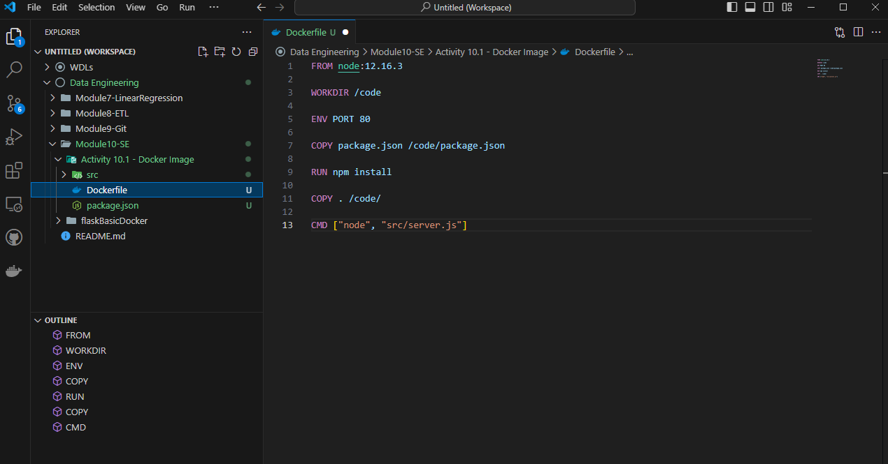
2. A black screen with white text

   Description automatically generated
3. A screen shot of a computer

   Description automatically generated
4. A black screen with white text

   Description automatically generated
5. 